Appendix 1b for Scott Wurcer’s Digital RIAA correction article in V0l 10

IIR Filter Coefficients for Archival Record Restoration

By separating the equalization into two steps, high frequency roll-off then low frequency roll-off and shelving, we can replicate Gary Galo’s archival pre-amp (An Archival Phono preamp, Gary Galo, Linear Audio Vol 5 pp 77) in digital form. The two halves here can be used in any combination and achieve a typical ~.005dB amplitude and ~3 degrees of phase accuracy. The filters should be used in the order listed, the high frequency roll-off first. The gains given for the two parts can be used to compute a net gain in order to adjust for the desired gain at 1 kHz. I would recommend splitting the difference i.e. if the gains for the two filters are 5dB and 7dB and you want a gain of 20dB at 1 kHz you would add 4dB to each (9dB and 11dB), so the sets of b coefficients would be multiplied by 2.8184 and 3.5481 respectively.
Sampling Frequency 48 kHz
10 kHz Attenuation
-5dB
poles = [6418.27187629, 35120.4669792]
zeros = [18130.3622713, 42879.3344526]
a coefficients = [ 1. -0.01468887 -0.1607727 ]
b coefficients = [ 1. 0.55992576 0.04050515]
Gain at 1kHz = 5.66812741487 dB
-7dB
poles = [4832.09607088, 33483.3710443]
zeros = [17928.473883, 41475.7124928]
a coefficients = [ 1. -0.14612491 -0.1939297 ]
b coefficients = [ 1. 0.54137053 0.03682934]
Gain at 1kHz = 7.40261919568 dB
-8.5dB
poles = [3974.68420219, 34053.3986055]
zeros = [18031.4370115, 42159.9145209]
a coefficients = [ 1. -0.20654927 -0.22344274]
b coefficients = [ 1. 0.55062849 0.03867224]
Gain at 1kHz = 8.65128049907 dB
-10dB
poles = [3289.14957263, 33796.8150103]
zeros = [18004.3849105, 41966.8234949]
a coefficients = [ 1. -0.26838466 -0.2436519 ]
b coefficients = [ 1. 0.5480884 0.03817634]
Gain at 1kHz = 9.86683901377 dB
-10.5dB
poles = [3092.30480714, 33717.4927835]
zeros = [17998.0877394, 41895.2104835]
a coefficients = [ 1. -0.28702638 -0.24963699]
b coefficients = [ 1. 0.54724606 0.03804071]
Gain at 1kHz = 10.2631636903 dB
-12dB (AES)
poles = [2574.55260356, 33350.8089624]
zeros = [17947.3135303, 41567.8490909]
a coefficients = [ 1. -0.33996657 -0.26444362]
b coefficients = [ 1. 0.54276496 0.03714026]
Gain at 1kHz = 11.4279415398 dB
-13.73dB (RIAA)
poles = [2112.13558715, 33306.8973142]
zeros = [17945.9351038, 41551.3073517]
a coefficients = [ 1. -0.3860447 -0.28092631]
b coefficients = [ 1. 0.54257034 0.03711006]
Gain at 1kHz = 12.6531891507 dB
-14.0dB
poles = [2027.65795756, 33336.0894595]
zeros = [17949.4676603, 41590.0335114]
a coefficients = [ 1. -0.39424389 -0.28439797]
b coefficients = [ 1. 0.54303428 0.03718469]
Gain at 1kHz = 12.8987226338 dB
-15.0dB
poles = [1801.65043157, 33224.8034955]
zeros = [17936.2697231, 41483.7216281]
a coefficients = [ 1. -0.4190493 -0.29193792]
b coefficients = [ 1. 0.54166248 0.03693511]
Gain at 1kHz = 13.58993174 dB
-16.0dB (NAB and Columbia LP)
poles = [1588.29116758, 33137.6007182]
zeros = [17924.9225667, 41404.0181067]
a coefficients = [ 1. -0.44281426 -0.2993899 ]
b coefficients = [ 1. 0.5405911 0.03672964]
Gain at 1kHz = 14.2913484223 dB
-20.0dB
poles = [1004.91346727, 32917.5993062]
zeros = [17895.7000785, 41198.5016204]
a coefficients = [ 1. -0.51059956 -0.3208049 ]
b coefficients = [ 1. 0.53781869 0.03620126]
Gain at 1kHz = 16.420161611 dB
Roll-off and Shelf Frequencies
30 Hz and 150 Hz
poles = [27003.8135511, 29.9999726294]
zeros = [27004.0489568, 149.995196697]
a coefficients = [ 1. -0.7187819 -0.27621199]
b coefficients = [ 1. -0.70325372 -0.27191111]
Gain at 1kHz = 0.0246687898456 dB
30 Hz and 200 Hz
poles = [29.9999718895, 26993.5046034]
zeros = [199.98856758, 26993.9305392]
a coefficients = [ 1. -0.71895815 -0.27603644]
b coefficients = [ 1. -0.69702994 -0.26996875]
Gain at 1kHz = 0.0700751919343 dB
30 Hz and 250 Hz
poles = [29.9999774363, 26997.7984047]
zeros = [249.977677252, 26998.469557]
a coefficients = [ 1. -0.71888473 -0.27610957]
b coefficients = [ 1. -0.69059729 -0.26828269]
Gain at 1kHz = 0.134774706261 dB
30 Hz and 300 Hz
poles = [26999.7749713, 29.9999412054]
zeros = [27000.7468423, 299.961288991]
a coefficients = [ 1. -0.71885094 -0.27614323]
b coefficients = [ 1. -0.68424479 -0.26656996]
Gain at 1kHz = 0.217530996271 dB
40 Hz and 400 Hz
poles = [26998.8496623, 39.9998269417]
zeros = [27000.5730477, 399.907894062]
a coefficients = [ 1. -0.71756375 -0.27576626]
b coefficients = [ 1. -0.67174396 -0.2631005 ]
Gain at 1kHz = 0.434161144839 dB
45 Hz and 450 Hz
poles = [26999.4846896, 44.9997404878]
zeros = [27001.6692794, 449.8690158]
a coefficients = [ 1. -0.71690203 -0.27559663]
b coefficients = [ 1. -0.66553442 -0.26140181]
Gain at 1kHz = 0.563321519695 dB
50.05 Hz and 500.5 Hz (RIAA)
poles = [27000.4683709, 50.0497911677]
zeros = [27003.1704285, 500.320253393]
a coefficients = [ 1. -0.71622826 -0.27543121]
b coefficients = [ 1. -0.659297 -0.25970356]
Gain at 1kHz = 0.705745669113 dB
100 Hz and 500.5 Hz
poles = [26998.6952235, 99.998525434]
zeros = [27001.3152559, 500.319746218]
a coefficients = [ 1. -0.70978402 -0.27360627]
b coefficients = [ 1. -0.65932878 -0.25967388]
Gain at 1kHz = 0.701736052893 dB
63 Hz and 625 Hz
poles = [62.9993705126, 27002.2456044]
zeros = [624.648717064, 27006.4587795]
a coefficients = [ 1. -0.71451526 -0.27499485]
b coefficients = [ 1. -0.64410122 -0.25555733]
Gain at 1kHz = 1.09828358133 dB
80 Hz and 800 Hz
poles = [79.9997284278, 26997.5099609]
zeros = [799.269456938, 27004.4100225]
a coefficients = [ 1. -0.71239155 -0.27430344]
b coefficients = [ 1. -0.6232679 -0.24973808]
Gain at 1kHz = 1.71614947984 dB
100 Hz and 1000 Hz
poles = [26992.1076368, 99.9989792423]
zeros = [27002.8846215, 998.57105572]
a coefficients = [ 1. -0.70989661 -0.27349508]
b coefficients = [ 1. -0.60002324 -0.24326203]
Gain at 1kHz = 2.46282363621 dB
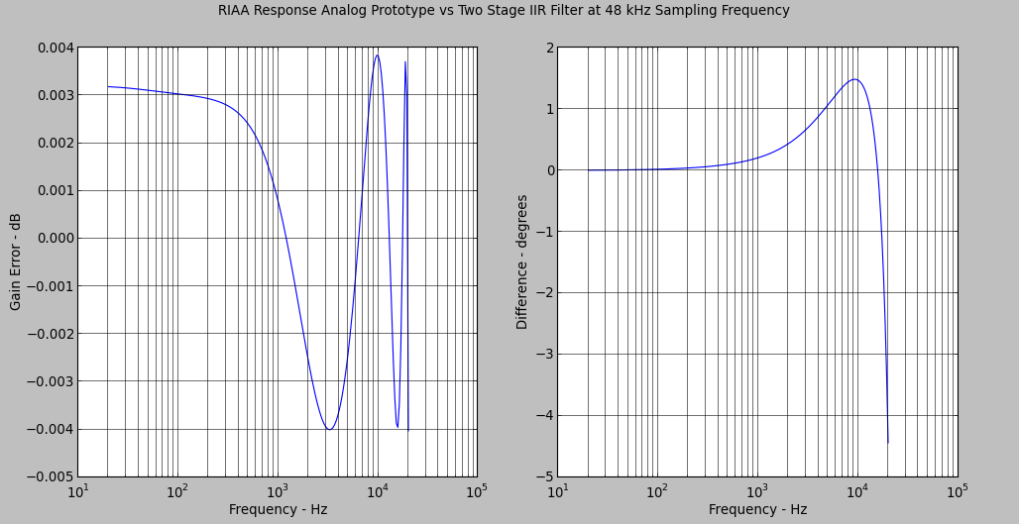
Typical Response for any Pair of Low/Shelf and High Cut Filters at 48 kHz

Sampling Frequency 96 kHz
10 kHz Attenuation
-5dB
poles = [6691.06043966, 62524.21194461]
zeros = [34857.42409556, 82552.26443945]
a coefficients = [ 1. -0.2973142 -0.22004364]
b coefficients = [ 1. 0.52540994 0.03021438]
Gain at 1kHz = 10.0726856161 dB
-7dB
poles = [4949.63232805, 63341.04069149]
zeros = [34885.76033979, 84417.86236809]
a coefficients = [ 1. -0.37207111 -0.25179758]
b coefficients = [ 1. 0.5345817 0.03098014]
Gain at 1kHz = 12.215840578 dB
-8.5dB
poles = [4032.41171857, 47440.49511742]
zeros = [33680.05888634, 60038.09528352]
a coefficients = [ 1. -0.55039598 -0.16598414]
b coefficients = [ 1. 0.37401055 0.01581647]
Gain at 1kHz = 13.5482093071 dB
-10dB
poles = [3319.93486936, 49514.83101752]
zeros = [33934.25854544, 62825.13647765]
a coefficients = [ 1. -0.56725588 -0.19034707]
b coefficients = [ 1. 0.39789403 0.01809083]
Gain at 1kHz = 14.9563046414 dB
-10.5dB
poles = [3117.18272972, 48532.6191727]
zeros = [33820.526391, 61513.25233735]
a coefficients = [ 1. -0.58759625 -0.18519468]
b coefficients = [ 1. 0.38689473 0.01703975]
Gain at 1kHz = 15.3958182123 dB
-12dB (AES)
poles = [2588.83047109, 48919.93647878]
zeros = [33866.05139144, 62057.17877833]
a coefficients = [ 1. -0.61275926 -0.19494682]
b coefficients = [ 1. 0.39146397 0.01746548]
Gain at 1kHz = 16.6971842041 dB
-13.73dB (RIAA)
poles = [2118.61024386, 46671.0547377]
zeros = [33577.71203556, 59118.30187446]
a coefficients = [ 1. -0.66168391 -0.18158841]
b coefficients = [ 1. 0.3655731 0.01499662]
Gain at 1kHz = 18.0272664045 dB
-14.0dB
poles = [2033.01304152, 47451.89355357]
zeros = [33684.32276289, 60129.8767453]
a coefficients = [ 1. -0.6586751 -0.18954618]
b coefficients = [ 1. 0.37475642 0.01587025]
Gain at 1kHz = 18.3014600429 dB
-15.0dB
poles = [1804.88191563, 44218.10744218]
zeros = [33187.24970088, 56086.24417916]
a coefficients = [ 1. -0.70577481 -0.16230729]
b coefficients = [ 1. 0.33588695 0.01215385]
Gain at 1kHz = 19.0276896532 dB
-16.0dB (NAB and Columbia LP)
poles = [1590.12988323, 47694.58635523]
zeros = [33715.881489, 60459.59945228]
a coefficients = [ 1. -0.68207946 -0.19733033]
b coefficients = [ 1. 0.37766487 0.01614252]
Gain at 1kHz = 19.8127700785 dB
-20.0dB
poles = [1004.63204637, 44487.1321567]
zeros = [33236.88865861, 56415.75402852]
a coefficients = [ 1. -0.75072587 -0.17379783]
b coefficients = [ 1. 0.33930531 0.01248588]
Gain at 1kHz = 22.0732627572 dB
Roll-off and Shelf Frequencies
30 Hz and 150 Hz
poles = [29.9999930157, 69998.9806658]
zeros = [149.998802661, 69999.2315101]
a coefficients = [ 1. -0.60580977 -0.39145928]
b coefficients = [ 1. -0.59800038 -0.38839831]
Gain at 1kHz = 0.0586598192928 dB
30 Hz and 200 Hz
poles = [29.9999901845, 70000.2166202]
zeros = [199.997146938, 70000.6604955]
a coefficients = [ 1. -0.6058023 -0.39146673]
b coefficients = [ 1. -0.59475652 -0.38713788]
Gain at 1kHz = 0.118182197719 dB
30 Hz and 250 Hz
poles = [29.9999910721, 69999.5297905]
zeros = [249.994432826, 70000.2294046]
a coefficients = [ 1. -0.60580645 -0.39146259]
b coefficients = [ 1. -0.59153447 -0.38587048]
Gain at 1kHz = 0.196970479248 dB
30 Hz and 300 Hz
poles = [29.9999919208, 69999.4265764]
zeros = [299.990376991, 70000.4266706]
a coefficients = [ 1. -0.60580707 -0.39146197]
b coefficients = [ 1. -0.58831915 -0.38461096]
Gain at 1kHz = 0.293787796074 dB
40 Hz and 400 Hz
poles = [39.9999772862, 69997.2651852]
zeros = [399.977189118, 69999.0185766]
a coefficients = [ 1. -0.60516714 -0.39119281]
b coefficients = [ 1. -0.58193089 -0.38209361]
Gain at 1kHz = 0.535620293901 dB
45 Hz and 450 Hz
poles = [44.9999698007, 70000.0261201]
zeros = [449.96753237, 70002.3000397]
a coefficients = [ 1. -0.60482411 -0.39108145]
b coefficients = [ 1. -0.57872834 -0.38086451]
Gain at 1kHz = 0.677342745575 dB
50.05 Hz and 500.5 Hz (RIAA)
poles = [50.0499639758, 69998.9836645]
zeros = [500.455331485, 70001.7913378]
a coefficients = [ 1. -0.60450091 -0.39094593]
b coefficients = [ 1. -0.57552742 -0.37960478]
Gain at 1kHz = 0.832424759841 dB
100 Hz and 500.5 Hz
poles = [99.9996526745, 69995.7842142]
zeros = [500.455340221, 69998.5100506]
a coefficients = [ 1. -0.60126704 -0.38965072]
b coefficients = [ 1. -0.57554725 -0.37958558]
Gain at 1kHz = 0.814259873612 dB
63 Hz and 625 Hz
poles = [62.9999228445, 69996.0891363]
zeros = [624.913027918, 70000.4688624]
a coefficients = [ 1. -0.60367396 -0.39059729]
b coefficients = [ 1. -0.56768154 -0.37651646]
Gain at 1kHz = 1.25591676037 dB
80 Hz and 800 Hz
poles = [79.9998424224, 69997.6612893]
zeros = [799.817636391, 70004.8291261]
a coefficients = [ 1. -0.60255701 -0.39017239]
b coefficients = [ 1. -0.55672326 -0.37225355]
Gain at 1kHz = 1.91732970428 dB
100 Hz and 1000 Hz
poles = [99.9996890508, 69991.4704225]
zeros = [999.643887354, 70002.6522354]
a coefficients = [ 1. -0.60129312 -0.38962481]
b coefficients = [ 1. -0.54439513 -0.36740018]
Gain at 1kHz = 2.71322497099 dB
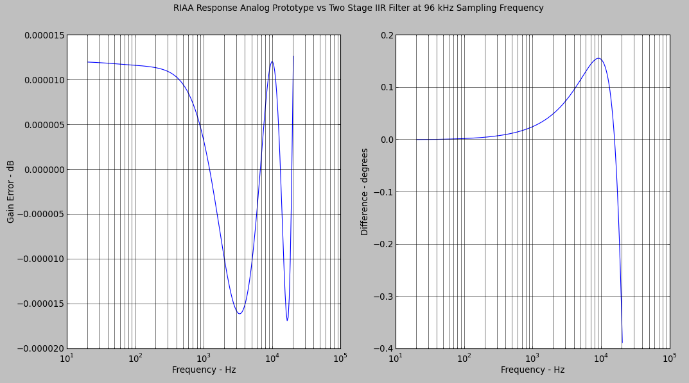
Typical Response for any Pair of Low/Shelf and High Cut Filters at 96 kHz

